WINTEC POS VENDING SYSTEM
OPERATOR MANUAL

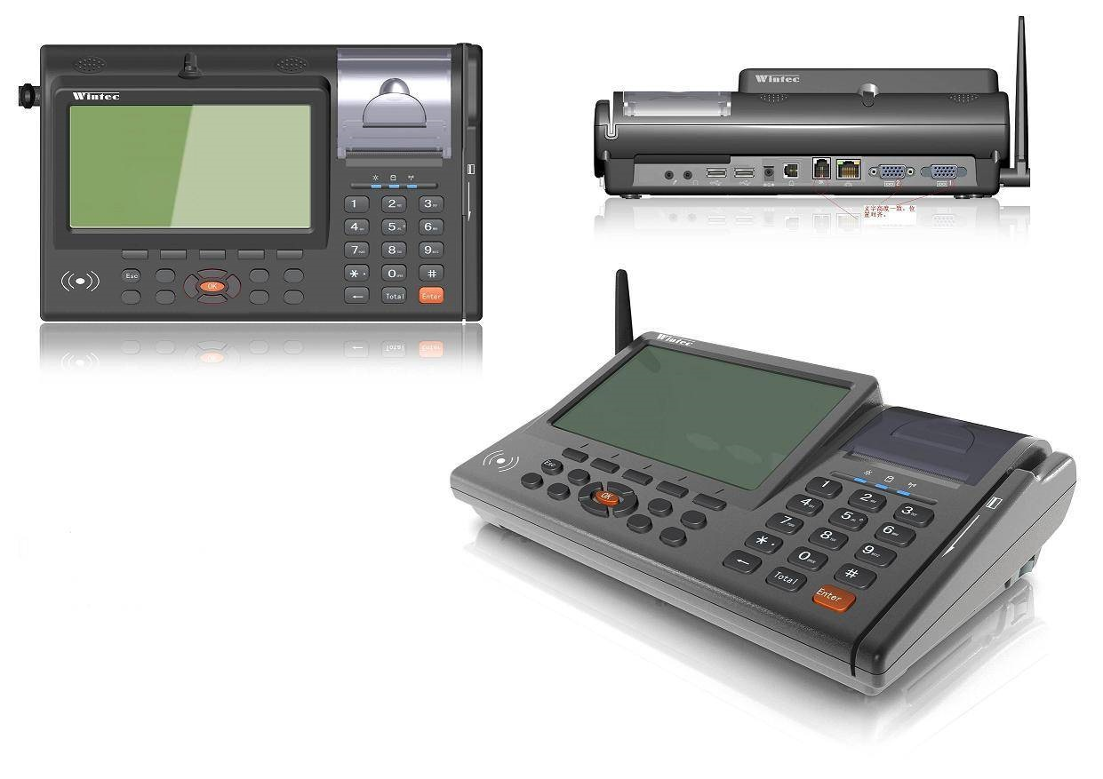

Table of Contents
1. ABOUT THIS MANUAL 1
2. SYSTEM OVERVIEW 2
3. GETTING STARTED 2
3.1. Touch keyboard icon to enter login details. 2
3.2. Click OK button to download new software update. 3
4. ELEC VEND APPLICATION 4
4.1. Click Elec Vend icon. 4

ABOUT THIS MANUAL
This manual is intended for operators of the Wintec POS System. It serves as a guide on how to use Wintec POS.
Operator refers to an individual with access to use Wintec POS to serve customers. Wintec POS has two types of operators: Cashier and Manager.

ICON DEFINITION
ICON  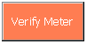  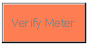   | DEFINITION  Selected Radio Button  Unselected Radio Button  Enabled Button  Disabled Button  Touch Keyboard  Dropdown List

SYSTEM OVERVIEW
Wintec POS System is the latest prepayment vending system from Syntell, to be used in retail outlets. The system runs on Wintec device, a hand held device which connects to SyntellPOS server through GPRS.
Syntell partners will be provided with a ready to use device, configured with services they wish to use.

GETTING STARTED
The first window you will see when opening the Wintec POS is the login window.
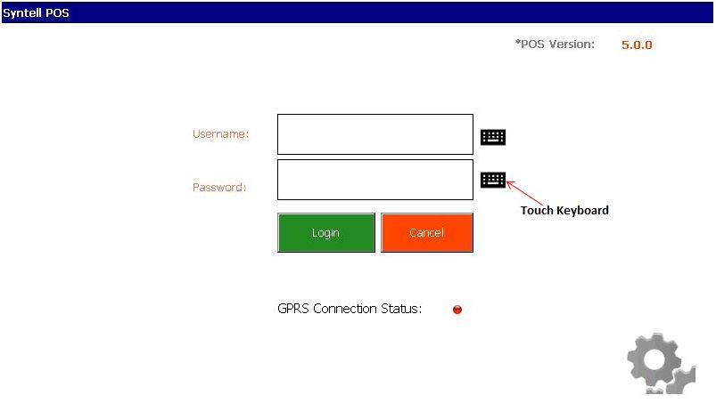
Figure 3-1: Login Screen

3.1. Touch keyboard icon to enter login details.
The manager will create unique login details (username and password) for each operator.

Login will NOT be prohibited on a second terminal if a user has already logged into the previous terminal. If the same operator signs onto 2 different terminals, 2 different bank batches with corresponding shifts will be created.
If there is a new software version available for download you will be redirected to the software download screen.

3.2. Click OK button to download new software update.
Software version is displayed on the right hand corner of the screen.

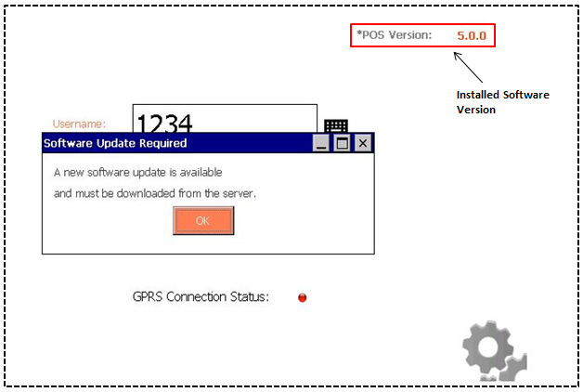
Figure 3-2: Software Update Required Screen
Once the download is complete, the system menu window will show. Make application selection.

ELEC VEND APPLICATION

4.1. Click Elec Vend icon.
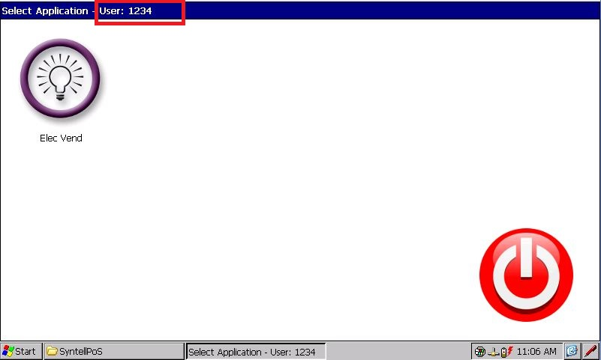
Current user’s username
Figure 4-1: Elec Vend Screen
Electricity Menu screen will be displayed with the available options.
If you are operating as a Cashier you should see a menu similar to the one shown below.
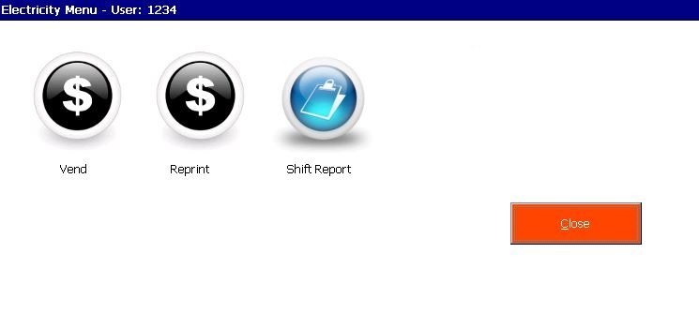
Figure 4-2: Cashier-Electricity Menu
If you are operating as a Manager you will have two additional items on the Menu.
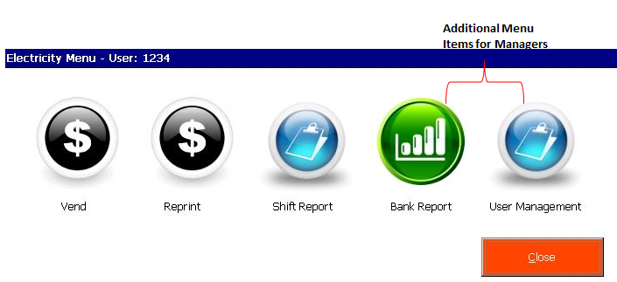
Figure 4-3: Manager’s Electricity Menu
VEND
4.2. Click vend icon for electricity vending.


The Customer Vending service has two options:
- Confirm customer details before vending.
- Vend to a customer.

To Confirm Customer
- Select Confirm Customer radio-button
- Select Authority
- Enter customer’s meter number

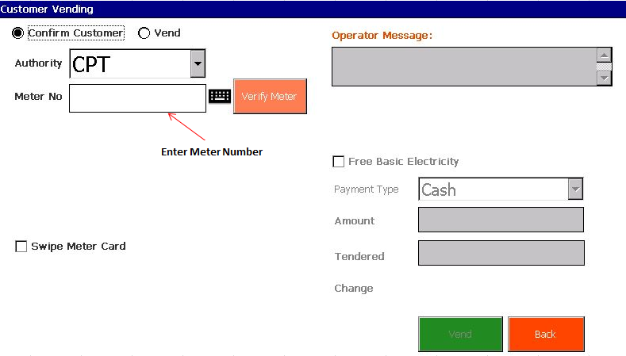
Or Select Swipe Meter Card to capture meter details.
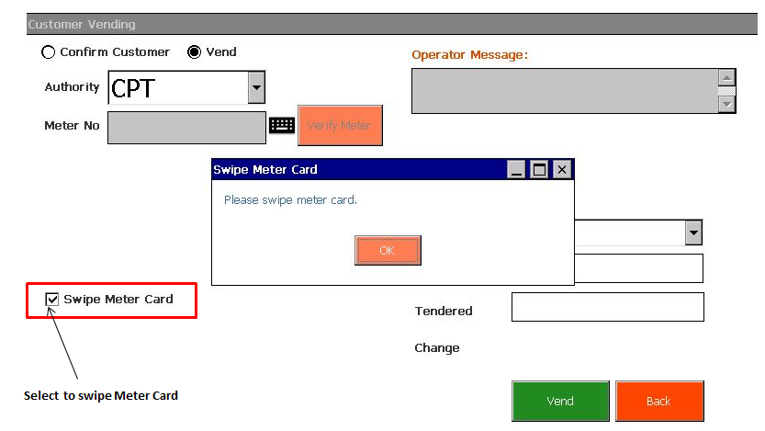
Figure 4-4: Verify Meter Screen

- Click Verify Meter button
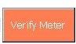
Customer details will be displayed. You may continue with the vending.

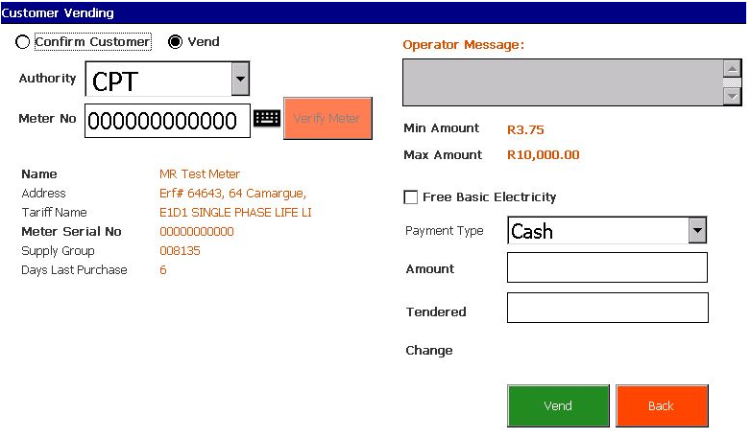
Figure 4-5: Confirm Customer details screen
To Vend: after verifying meter details.
- Select Payment Type.
- Enter Purchase Amount.
- Enter Tendered Amount.
- The system will calculate the change due to the customer.
- Click Vend button to complete the vending.
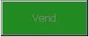

For free units select FBE Basic Electricity checkbox
Payment fields will be set to R0 and disabled.
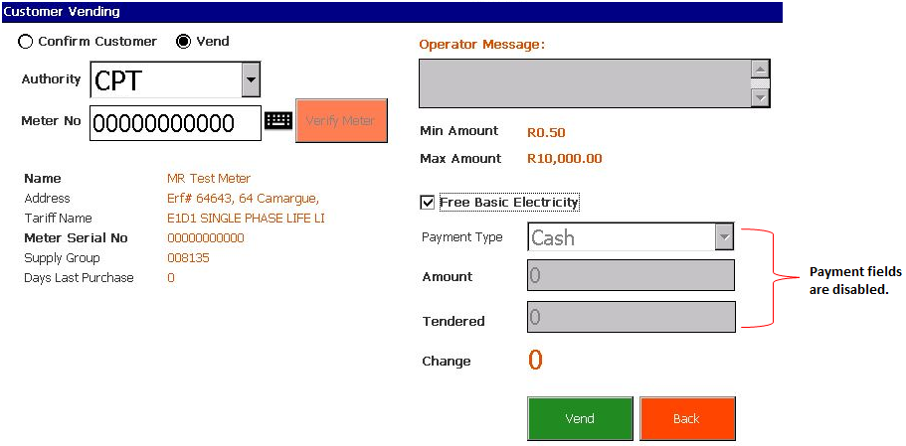
Figure 4-6: FBE Basic Electricity Screen

To Vend: without verifying meter details
- Select Vend radio-button.
- Select Authority.
- Enter meter number or swipe card.
- Do steps 1-5 from To Vend: after verifying meter details (see above).
If the sale transaction is successful a fiscal receipt will be printed. See below an example of a receipt.

CITY OF CAPE TOWN
***Reprint***
Receipt Number: 259941402988
VAT Reg. No: 3988339883
POS ID: SynP0S00000003 POS Name:
Name :Adene Jonah
Address: Mr John Linde 34 Tokai
Meter: 00000000000
SGC: 100405 T1:52
KRN: 1
Token Tech: 02
Alg Tech: 05
Tariff:
Date: 22/04/2014 Time:10:18:05

FBE Units: 0
Units: 33.333332
Refunded Units:

Cost of elec (excl) 6.32
Debt Recovery : 1.70
Srv charge (excl) : 1.10

VAT : 0.88
Total : 9.12
Grand Total : 10.00
Amount Tendered : 10.00
Change : 0.00
Total units : 33.333332

Token: 7500 4285 3826
2167 4496

Powered by Syntell

If the transaction is not successful informative error message will be displayed. Below are examples of error messages that may be displayed.

- Vend amount is greater than tendered amount.
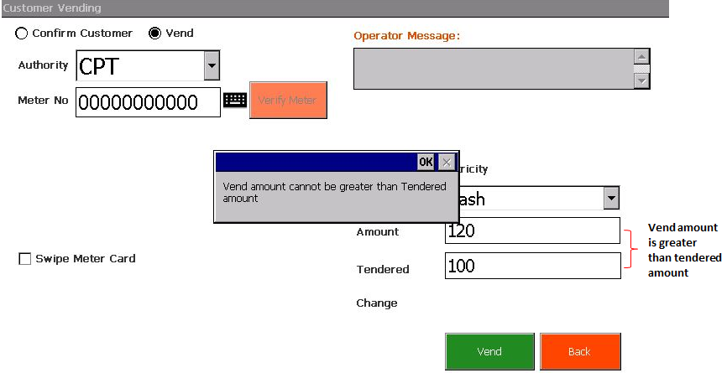
- Server error
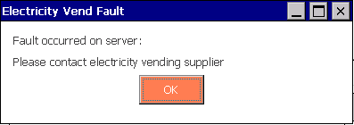

- Session timed out message: if the system remains idle for certain period.
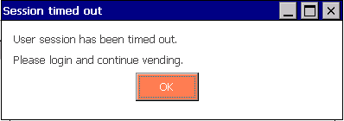

REPRINT
A mechanism that enables an Operator to reprint customer’s lost token receipt.
To Reprint Token follow the steps below:
- Click Reprint icon from the Electricity menu.

Reprint Screen will show.
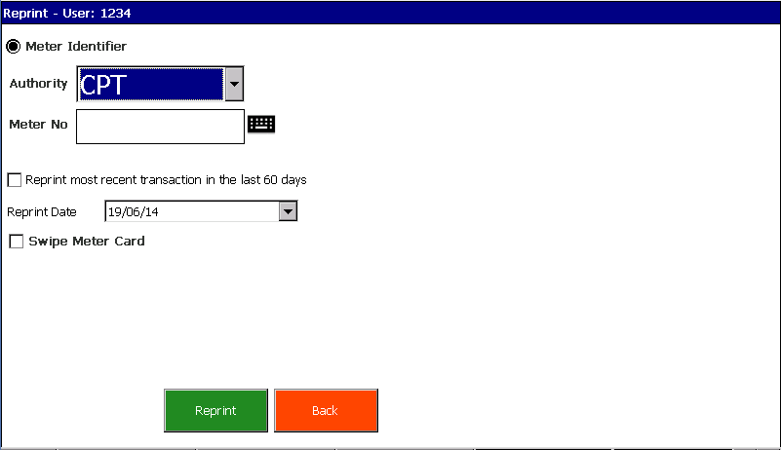
Figure 4-6: Reprint Screen
- Select Authority
- Use a touch keyboard to enter Meter Number or tick Swipe Card Checkbox

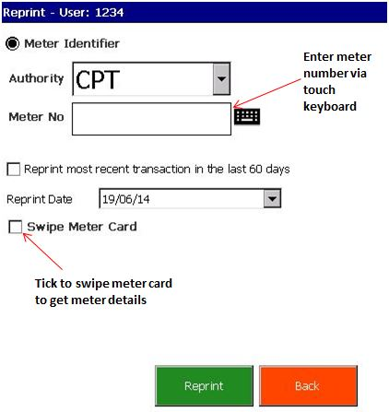

- Select transaction date from the Calender dropdown or tick Reprint most recent transaction in the last 60 days checkbox.

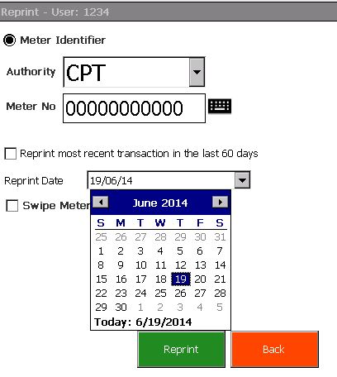

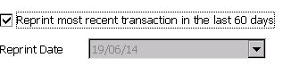

- Click Reprint button
- Wintec POS will do a lookup and print last transaction reciept.

Shift Report
A shift will be opened when an Operator completes the first vend for the day.
For S3, Banks and Shifts will be created on S3 POSID and operator that we will send in the request to S3.

Description:
A shift report is a summary of all transactions for the day by the Operator.This must be done at the end of each shift.
- Select Shift Report icon from Electricity Menu.

- Shift Report is printed.

There are 2 types of shifts:
- Remote Shift Report
- Local Shift Report
Remote Shift Report:
If the municipaltity supports shift functionality, the shift report details will be extracted directly from the municipality.
Local shift Report:
If the municipaltity does not support shift functionality, the shift report details will be extracted from the local database.
When a terminal has access to more than one municipality, the shift report will be printed grouped by municipality, with the totals displayed at the bottom of the report.
If the Operator forgets to manually close the shift, there will be a scheduled job (configurable) which checks if there are any open shifts for any operators and will be closed automatically.

Bank Report
A bank batch will be created when the first vend for the day has been completed on the terminal which also creates the shift for that specific Operator.
The same bank batch number will be used for all the Operators’ shifts for the day.
For S3, Banks and Shifts will be created on S3 POSID and operator that we will send in the request to S3.

Description:
A bank report is a summary of all shifts for the day by all Operators.This must be done at the end of each day.

This report is available to managers only, it displays a summary of all shifts. This includes the total amount ( in Rands) and total units sold for the day.
To Print a Bank Report:
- Select Bank Report from Electricity Menu.

- Bank Report for the day is printed.

There are 2 types of bank reports:
- Remote Bank report
- Local Bank report
Remote Bank Report:
If the municipaltity supports bank report functionality, the bank report details will be extracted directly from the municipality.
Local Bank Report:
If the municipaltity does not support bank report functionality, the bank report details will be extracted from the local database.

When a terminal has access to more than one municipality, the bank report will be printed grouped by municipality, with the totals displayed at the bottom of the report.
If the Manager forgets to manually close the bank report, there will be a scheduled job (configurable) which checks if there is a open bank batch and will be closed automatically.

User Management
Another additional item for Managers, to create and manage Wintec POS users.
- Select User Management from Electricity Menu.

User Management Screen will appear with three options.
- Register
- Update
- Delete

To Register New User
- Select Register Radiobutton.
- Enter username and password (unique for each user).
- Enter user’s FirstName and SurName.
- Fill in the Min and Max Transactional Limit(for vending).
- Choose userGroup: Cashier or Manager.
- Click Register to complete the registration process.

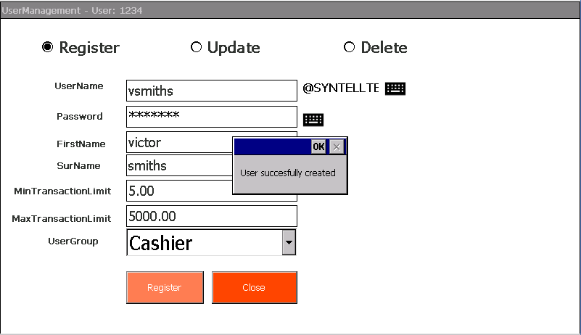
Figure 4-8: New User Registration

To Update Existing User’s Details
- Select UPDATE radiobutton.
- Update screen will display as shown below.
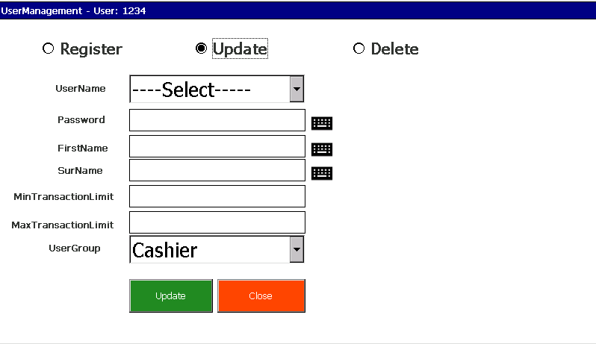
Figure 4-9: Update User’s Details
- Select a user profile to update from the UserName Dropdown list.
User’s details will be displayed and available for changes.
- To finish off the changes click UPDATE button.
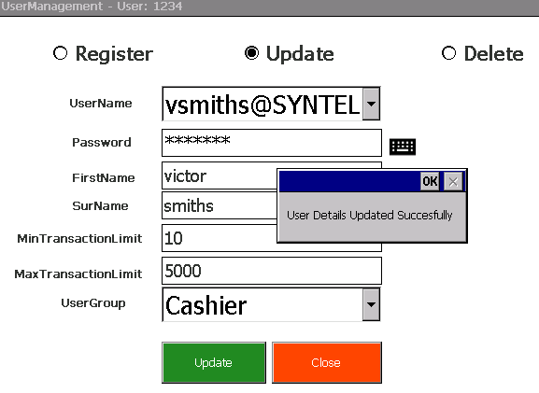
Figure 4-10: Update Successful

To Delete Existing User Profile
- Select Delete radio button, the delete screen will appear.
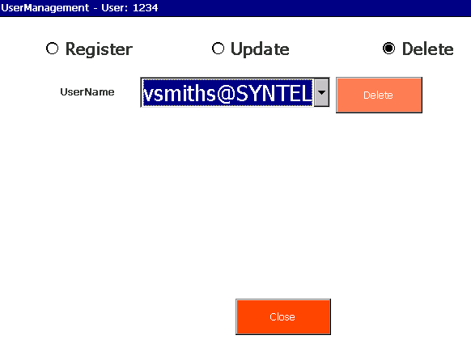
Figure 4-11: Delete User Profile Screen
- Select UserName you want to delete from the UserName dropdown list.
- Click Delete. User Profile removed.

--------------------------End--------------------------

